Radiius Corp.

Jacket and Card

Applet Specification
Version 0.6 08/09/2015

TABLE OF CONTENTS

DOCUMENT CHANGE HISTORY 4
1. Overview 5
1.1 Referenced Documents 5
2. Jacket Applet 7
2.1 SELECT 8
2.2 PUT DATA 9
2.3 GET DATA 11
2.4 VERIFY PIN 12
2.5 UNBLOCK PIN 14
2.6 CHANGE PIN 15
2.7 CREATE CARD 17
2.8 UPDATE CARD 19
2.9 DELETE CARD 20
2.10 GET CARD 22
2.11 VALIDATE 24
2.12 PAIR 26
2.13 Data Dictionary 27
3. Card Applet 28
3.1 SELECT 28
3.2 PUT DATA 29
3.3 GET DATA 31
3.4 VALIDATE 32
3.5 Data Dictionary 34
Appendix A – Key Definitions 35
A.1 Authentication between Card and Jacket 35
A.2 Pairing with the handset 35
Appendix B – Jacket and Card Applet Personalization Process 37
Appendix C – Standard APDU Definitions 38
C.1 Global Platform APDU 38
C.2 EMV Co APDU 39
C.3 Visa Applet 39
C.4 MasterCard 39
C.5 American Express Applet 39
C.6 DPAS Applet 39
Appendix D – Sample use cases 40
D.1 Jacket and Card Mutual Authentication 40
D.2 Add and update a new card 41
D.3 Card selection and lock 42
D.4 Pair with the handset 43
D.5 Retrieve the secure data 44

DOCUMENT CHANGE HISTORY

Date of Issue | Version | Description | Remarks
28-Aug-15 | V0.1 | First release
31-Aug-15 | V0.2 | Added some message sequence charts.
01-Sept-15 | V0.3 | Updated after review comments
03-Sept-15 | V0.4 | Updated to define the card TLV more clearly
07-Sept-15 | V0.5 | Specified the package and applet AIDs
08-Sept-15 | V0.6 | Updated the Get Data for the Card applet.

1. Overview

This document forms the requirement specification for the Radiius applet residing in the secure elements of the Jacket and the card components of the Radiius OneCard product.

It is assumed that each applet is hosted on a Java Card based Secure Element (SE) that implements Global Platform.

The purpose of this document is to provide sufficient detail to allow an applet developer to implement the applets.

Section 2 defines the functionality of the Radiius applet for the Jacket SE.

Section 3 defines the functionality of the Radiius applet for the Card SE.

As a guide Appendix A defines the keys that are used in the Jacket and Card during the operational phase.

As a guide Appendix B describes a typical personalization process.

Appendix C defines the Global Platform APDUs that are required to a) instantiate and b) activate the payment applet prior to a transaction.

In addition Appendix C defines the payment APDUs defined by the various schemes to indicate that CVM has been performed and if necessary to clear the CVM status.

Note: That the details of the payment applets hosted on the Card SE are beyond the scope of this document.

Appendix D provides message sequence charts to illustrate to illustrate how the APDUs are used.

1.1 Relevant Documents

[GP] | Global Platform Card Specification Version 2.2.1 January 2011
[VMCPS] | Visa Mobile Contactless Payment Specification (VMCPS) Version 1.4,3. May 2015
[EMV_UI] | EMVCo Contactless Mobile Payment Application Activation User Interface Overview, Usage Guidelines and PPSE requirements Version 1.0 December 2010

2. Jacket Applet
The Jacket Applet will implement the Card Store, handle pairing with the handset and vaaallliidation of the Card.

The following AIDs have been assigned to the Jacket:
- Package AID is set to 524144000000 in hexadecimal.
- Applet AID is set to 5241440000000010 in hexadecimal.

Table 2.1 below provides a summary of the APDUs that need to be handled by the Jacket Applet. A detailed description of each APDU will be given in the following sub-sections.

The Jacket applet may be in one of several states dependent on the actions performed, these are shown in the table below. The state determines which APDUs that can be invoked.

State | Description
INSTALLED | This is the initial state of the applet when instantiated using the Global Platform INSTALL APDU.
PERSONALIZED | This is state that the applet moves to when all the data has been personalized using the PUT DATA APDU from the perso. script.
READY | This is the state that the applet moves to when it has paired with the handset and the PIN and been changed.

Note: that the SELECT APDU is defined by Global Platform, see [GP], but the Jacket Applet may respond to it.

CLA | INS | Function | Issued by | Applet State | DATA
0x00 | 0xA4 | SELECT | Off card entity | ALL | Is used whenever the applet needs to be selected. This happens during personalization and from the Jacket MCU.
0x80 | 0xDA | PUT DATA | Perso script | INSTALLED or from a script | During personalization this is used to load various data elements. The specific data item is defined by P1 and P2.
0x80 | 0xCA | GET DATA | Jacket MCU | ALL | Used to read data items from the SE, The specific data item is defined by P1 and P2.  Note: only specific data items may be read from the SE in any given state.
0x80 | 0xB0 | VERIFY PIN | Jacket MCU | PERSONALISED or READY | Validates the PIN entered by the user.
0x84 | 0xB2 | UNBLOCK PIN | Jacket MCU | PERSONALISED or READY | Unblocks the PIN that has – this has to be issued from a script sent by the Radiius Server.
0x80 | 0xB4 | CHANGE PIN | Jacket MCU | PERSONALISED or READY | Changed the existing PIN to a new value entered by the user.
0x80 | 0xB6 | CREATE CARD | Jacket MCU | READY | Adds card data to the store in the secure element
0x80 | 0xB8 | UPDATE CARD | Jacket MCU | READY | Adds card data to the store in the secure element
0x80 | 0xBA | DELETE  CARD | Jacket MCU | READY | Deletes a card data from the store in the secure element
0x80 | 0xBC | GET  CARD | Jacket MCU | READY | Reads card data from the store in the secure element
0x80 | 0xC0 | VALIDATE | Jacket MCU | PERSONALISED  And  READY | Selects a specific applet as defined by the AID in the command data.
0x80 | 0xC2 | PAIR | Jacket MCU | PERSONALISED  And  READY | Support mutual authentication between the handset and the Jacket.

2.1 SELECT

The select is a standard command defined in [GP] and has the parameters defined in Table 2.1.1.

2.1.1 Command Message
The select command is coded as follows:

Field | Value
CLA | 0x00
INS | 0xA4
P1 | 0x04
P2 | 0x00
LC | Length of the AID
Data | AID of the applet.
Le | 0x00

2.1.1 Processing
No applet specific processing has been identified for this APDU.

2.1.3 Response Data
No response data has been identified for this APDU.

2.1.4 Status response
The status responses returned by the applet are standard and defined in [GP] section 11.9.3.2 and are generated by the platform with no action from the applet, these are summarized below.

Status | Description
0x6400 | No specific diagnosis
0x6700 | Wrong length in Lc
0x6881 | Logical channel not supported or is not active
0x6982 | Security status not satisfied
0x6985 | Conditions of use not satisfied
0x6A86 | Incorrect P1 P2
0x6D00 | Invalid instruction
0x6A82 | Selected Applet not found
0x9000 | Success

2.2 PUT DATA

The PUT DATA command is used to load data into the secure element.

This command is only valid before personalization – after that any attempt will issue an invalid status.

The specific data element loaded is determined by P2 parameter.

2.2.1 Command Message
The select command is coded as follows:

Field | Value
CLA | 0x80
INS | 0xDA
P1 | Set to MSB to:  0 if this is not the last data element  1 if this is the last data element  The remaining 7 bits form the upper part of the data element tag.
P2 | Tag of the data item to be loaded.
LC | Length of the data
Data | Data to be loaded
Le | 0x00

2.2.2 Processing

Upon receipt of the command the applet will:
- Check for a valid class and instruction, if invalid exit with a status of 6D00.
- Check that the length is consistent with the command data, if invalid exit with a status of 6700.
- Check that the P2 value identifies a valid data item, if invalid exit with a status of 6A86.
- Check to ensure that the data can be modified in the current lifecycle state, if invalid exit with a status of 6985.
- Verify that a secure channel has been established, if not exit with a status of 6982.
- If P1 indicated that this is the last data item to load:
  - The applet must ensure all data items have been loaded, if not exit with a status of 6982.
  - Otherwise change the lifecycle state to PERSONALIZED
- If all is well, the data field is used to update the specified parameter and a status of 9000 is returned.

The valid data items that can be stored are:

Tag | State | Description
0x0001 | INSTALLED | Jacket hash
0x0002 | INSTALLED | Card Hash
0x0004 | INSTALLED | Card AES Key for pairing with the card
0x0008 | INSTALLED | Initial PIN
0x0010 | INSTALLED | Jacket Private Key CRT q⁻¹ mod p
0x0020 | INSTALLED | Jacket Private Key CRT d mod (q-1)
0x0040 | INSTALLED | Jacket Private Key CRT d mod (p-1)
0x0080 | INSTALLED | Jacket Private Key CRT prime factor q
0x0100 | INSTALLED | Jacket Private Key CRT prime factor p

2.2.3 Response Data
No response data has been identified for this APDU.

2.2.4 Status response
The applet validates the input parameters may generate one of the following status values.

Status | Description
0x6700 | Wrong length in Lc
0x6D00 | Invalid class or instruction.
0x6982 | Security status not satisfied
0x6985 | Conditions of use not satisfied
0x6986 | Security conditions not satisfied
0x6A86 | Incorrect P1 P2
0x9000 | Success

2.3 GET DATA

The GET DATA command is used to retrieve data from the secure element.

The specific data element loaded is determined by P2 parameter.

2.3.1 Command Message
The select command is coded as follows:

Field | Value
CLA | 0x00
INS | 0xCA
P1 | MS Byte of the Tag to be retrieved
P2 | LS Byte of the Tag to be retrieved
LC | Not present – no command data
Data | Not present
Le | 0x00

2.3.2 Processing

Upon receipt of the command the applet will:
- Check for a valid class and instruction, if invalid exit with a status of 6D00.
- Check that the P2 value identifies a valid data item, if invalid exit with a status of 6A86.
- Check to ensure that the data can be retrieved in the current lifecycle state, if invalid exit with a status of 6985.
- Verify that the Jacket has been paired with the handset, if not exit with status 6982.
- If all is well, copy the value of the tagged data to the response field and return a status of 9000.

The valid data items that can be stored are:

Tag | State | Description
0xFF | ALL | The Applet version number – a build constant.

2.3.3 Response Data

The response data is defined as:

- Tag read
- Length of the data
- Data read

2.3.4 Status response
The applet validates the input parameters may generate one of the following status values.

Status | Description
0x6D00 | Invalid class or instruction.
0x6985 | Conditions of use not satisfied
0x6982 | Security status not satisfied
0x6A86 | Incorrect P1 P2
0x9000 | Success

2.4 VERIFY PIN

The VERIFY PIN command is used to verify the user PIN, this is used:

- During activation prior to fingerprint activated.
- As an alternative to the fingerprint if an exception is in place.

2.4.1 Command Message
The select command is coded as follows:

Field | Value
CLA | 0x80
INS | 0xB0
P1 | 0x00
P2 | 0x00
LC | Length of command data
Data | Command Data – encrypted with the Jacket public key, see below.
Le | 0x00

The command data is made up of a concatenation of the following:

- Length of the unique handset fingerprint
- Unique handset fingerprint
- Length of the PIN
- ASCII representation of the PIN
- Padding of 0xFF to the size of the Jacket public key.

The concatenated data is then encrypted using the Jacket public key.

2.4.2 Processing

Upon receipt of the command the applet will:
- Check for a valid class, if invalid exit with a status of 6E00.
- Check for a valid instruction, if invalid exit with a status of 6D00.
- Check that the P1 and P2 are 0, if invalid exit with a status of 6A86.
- Check to ensure that the applet is in a valid lifecycle state, if invalid exit with a status of 6985.
- If all is well the applet will decrypt the command data using the Jacket private key.
- If the handset fingerprint has not been saved
  - Save the handset fingerprint as the paired device.
- Otherwise
  - Compare the APDU handset fingerprint with the paired one, if they don’t match exit with status 6985.
- Compare the PIN if it does not match the current PIN:
  - If the number of retries has been decremented to 0, exit and return a status of 6983 blocked.
  - Otherwise the exit and return a status of 63CX where X is the number of retries available.
- If the PIN requires changing, exit with a status of 90FF.
- Exit with a status of 9000.

2.4.3 Response Data

No response data is required for the VERIFY PIN.

2.4.4 Status response
The applet validates the input parameters may generate one of the following status values.

Status | Description
0x6E00 | Invalid class.
0x6D00 | Invalid instruction.
0x6A86 | Incorrect P1 P2
0x6985 | Conditions of use not satisfied
0x6983 | PIN Blocked
0x63CX | Incorrect PIN with X retries available
0x9000 | Success
0x90FF | Success but PIN change required

2.5 UNBLOCK PIN

The UNBLOCK PIN command reset a PIN blocked by a user.

This command is only valid when issues as part of a script over a Global Platform defined secure channel, see [GP]. The secure channel will encrypt and MAC the script APDUs to protect the PIN data.

2.5.1 Command Message
The select command is coded as follows:

Field | Value
CLA | 0x84
INS | 0xB2
P1 | 0x00
P2 | 0x00
LC | Length of the data
Data | New ASCII PIN value
Le | 0x00

2.5.2 Processing

Upon receipt of the command the applet will:
- Check for a valid class, if invalid exit with a status of 6E00.
- Check for a valid instruction, if invalid exit with a status of 6D00.
- Check that a secure connection has been established, if not exit with a status of 6982.
- Check that the length is consistent with the command data, if invalid exit with a status of 6700.
- Check that the P1 and P2 are 0, if invalid exit with a status of 6A86.
- Update the PIN with the new value, reset the internal state too indicate that the PIN must be changed and return a status of 0x90FF.

2.5.3 Response Data
No response data has been identified for this APDU.

2.5.4 Status response
The applet validates the input parameters may generate one of the following status values.

Status | Description
0x6D00 | Invalid class.
0x6E00 | Invalid instruction.
0x6982 | Security status not satisfied
0x6700 | Wrong length in Lc
0x6A86 | Incorrect P1 P2
0x90FF | Success but PIN change required

2.6 CHANGE PIN

The CHANGE PIN command allows the user to change the PIN as required.

Note: That a change PIN is required when:
- first activating the Jacket,
- is unblocked via a script from the payment server or
- when requested by the user.

2.6.1 Command Message
The select command is coded as follows:

Field | Value
CLA | 0x80
INS | 0xB4
P1 | 0x00
P2 | 0x00
LC | Length of command data
Data | Command Data – encrypted with the Jacket public key, see below.
Le | 0x00

The command data is made up of a concatenation of the following:

- Length of the unique handset fingerprint
- Unique handset fingerprint
- Length of the existing PIN
- ASCII representation of the existing PIN
- Length of the new PIN
- ASCII representation of the new PIN
- Padding of 0xFF to the size of the Jacket public key.

The concatenated data is then encrypted using the Jacket public key.

2.6.2 Processing

Upon receipt of the command the applet will:
- Check for a valid class, if invalid exit with a status of 6E00.
- Check for a valid instruction, if invalid exit with a status of 6D00.
- Check that the P1 and P2 are 0, if invalid exit with a status of 6A86.
- Check to ensure that the applet is in a valid lifecycle state, if invalid exit with a status of 6985.
- Verify that the Jacket has paired with the handset, if not exit with status 6982
- If all is well the applet will decrypt the command data using the Jacket private key.
- If the PIN does not match the current PIN:
  - If the number of retries has been decremented to 0, exit and return a status of 6983 blocked.
  - Otherwise the exit and return a status of 63CX where X is the number of retries available.
- Check the handset fingerprint matches the applet version, if invalid exit with a status of 6985.
- Otherwise save the new PIN, set the number of retries to the maximum and return with a status of 9000.

2.6.3 Response Data

No response data is required for the CHANGE PIN.

2.6.4 Status response
The applet validates the input parameters may generate one of the following status values.

Status | Description
0x6E00 | Invalid class.
0x6D00 | Invalid instruction.
0x6A86 | Incorrect P1 P2
0x6982 | Security status not satisfied
0x6985 | Conditions of use not satisfied
0x6983 | PIN Blocked
0x63CX | Incorrect PIN with X retries available
0x9000 | Success

2.7 CREATE CARD

This command updated the selected card.

2.7.1 Command Message
The select command is coded as follows:

Field | Value
CLA | 0x80
INS | 0xB6
P1 | Indicates the card type to be updated:  0x00 – Loyalty  0x01 – Payment  0x02 – Other
P2 | Indicates whether the payload is encrypted with the Jacket Public Key  0x00 – Plain text  0x01 – Encrypted  Note that if the command data contains any of the following it MUST be encrypted: PAN, CVV and Expiry Date.
LC | Length of command data
Data | The command consists of the CID optionally followed by a series of TLV to set specific fields of the card. The fields are shown in Table 2.7.1 Below.
Le | 0x00

The command data takes one of 2 forms.

Form 1, plaintext:
- CID of the card
- Length of concatenated TLVs
- The concatenated TLVs

Form 2, the following data is encrypted with the Jacket public key:
- CID of the card
- Length of handset fingerprint
- Handset fingerprint
- Length of concatenated TLVs
- The concatenated TLVs
- Padding out to the key length.

Tag | Length | Secured | Description
1 | 1 | N | State of the card
2 | 13 | N | User interface string
3 | Max 79 | N | Track 1 data – dependent on the type of card
4 | Max 40 | N | Track 2 data – dependent on the type of card
5 | Max 107 | N | Track 3 data – dependent on the type of card
6 | Max 16 | N | AID of the payment card
7 | Max 32 | N | Label of the payment card
8 | Max 16 | Y | PAN of the payment card
9 | 4 | Y | CVV of the payment card, if the length is less than 4 pair with spaces.
10 | 5 | Y | Expiry date of the payment card
11 | 1 | N | Category of card – set by handset UI
12 | 1 | N | Purpose of card – set by handset UI
13 | 1 | N | Card image identifier – set and used by the handset UI

Table 2.7.1 Card TLV Tags

Note: If any of the secure items are included the complete payload must be encrypted.

2.7.2 Processing

Upon receipt of the command the applet will:
- Check for a valid class, if invalid exit with a status of 6E00.
- Check for a valid instruction, if invalid exit with a status of 6D00.
- Check that the P2 are 0, if invalid exit with a status of 6A86.
- Check to ensure that the applet is in a valid lifecycle state, if invalid exit with a status of 6985.
- Verify that the Jacket has paired with the handset, if not exit with status 6982
- Look for a matching card, if it can be found exit and return a status of 6984.
- While there is command data left
  - Extract the next tag, if it is not valid for the card type exit with status 6984
  - Extract the length of the tag, if it does not the length of the data element exit with status 6984
  - Otherwise update the data element.
- Exit with status of 9000.

2.7.3 Response Data

No response data is required for the CREATE CARD.

2.7.4 Status response
The applet validates the input parameters may generate one of the following status values.

Status | Description
0x6E00 | Invalid class.
0x6D00 | Invalid instruction.
0x6A86 | Incorrect P1 P2
0x6985 | Conditions of use not satisfied
0x6982 | Security status not satisfied
0x6984 | Invalid data – existing card with the same CID or invalid TLV data.
0x9000 | Success

2.8 UPDATE CARD

This command updated the selected card.

2.8.1 Command Message
The select command is coded as follows:

Field | Value
CLA | 0x80
INS | 0xB8
P1 | Indicates the card type to be updated:  0x00 – Loyalty  0x01 – Payment  0x02 – Other
P2 | Indicates whether the payload is encrypted with the Jacket Public Key  0x00 – Plain text  0x01 – Encrypted  Note that if the command data contains any of the following it MUST be encrypted: PAN, CVV and Expiry Date.
LC | Length of command data
Data | The command consists of the CID followed by a series of TLV to identify the fields being updated. The fields are shown in Table 2.8.1 Below.
Le | 0x00

The command data takes one of 2 forms.

Form 1, plaintext:
- CID of the card
- Length of concatenated TLVs
- The concatenated TLVs

Form 2, the following data is encrypted with the Jacket public key:
- CID of the card
- Length of handset fingerprint
- Handset fingerprint
- Length of concatenated TLVs
- The concatenated TLVs
- Padding out to the key length.

The list of supported TLVs is shown in table 2.7.1 above.

2.8.2 Processing

Upon receipt of the command the applet will:
- Check for a valid class, if invalid exit with a status of 6E00.
- Check for a valid instruction, if invalid exit with a status of 6D00.
- Check that the P1 and P2 are valid, if invalid exit with a status of 6A86.
- Check to ensure that the applet is in a valid lifecycle state, if invalid exit with a status of 6985.
- Verify that the Jacket has paired with the handset, if not exit with status 6982
- Find the matching card, if it can’t be found return a status of 6984.
- If P2 indicates that the command data is encrypted, decrypt it using the Jacket private key.
- While there is command data left
  - Extract the next tag, if it is not valid for the card type exit with status 6984
  - Extract the length of the tag, if it does not the length of the data element exit with status 6984
  - Otherwise update the data element.
- Exit with status of 9000.

2.8.3 Response Data

No response data is required for the UPDATE CARD.

2.8.4 Status response
The applet validates the input parameters may generate one of the following status values.

Status | Description
0x6E00 | Invalid class.
0x6D00 | Invalid instruction.
0x6A86 | Incorrect P1 P2
0x6985 | Conditions of use not satisfied
0x6982 | Security status not satisfied
0x6984 | Invalid data – no matching CID or invalid TLV data.
0x9000 | Success

2.9 DELETE CARD
This command deletes the selected card from the secure elements records.

2.9.1 Command Message
The select command is coded as follows:

Field | Value
CLA | 0x80
INS | 0xBA
P1 | Indicates the card type to be updated:  0x00 – Loyalty  0x01 – Payment  0x02 – Other
P2 | 0x00
LC | Length of command data
Data | Identifier of the target card.
Le | 0x00

2.9.2 Processing

Upon receipt of the command the applet will:
- Check for a valid class, if invalid exit with a status of 6E00.
- Check for a valid instruction, if invalid exit with a status of 6D00.
- Check that the P1 and P2 are valid, if invalid exit with a status of 6A86.
- Check to ensure that the applet is in a valid lifecycle state, if invalid exit with a status of 6985.
- Verify that the Jacket has paired with the handset, if not exit with status 6982
- Find the matching card, if it can’t be found return a status of 6984
- Change the state to the requested one.

2.9.3 Response Data

No response data is required for the DELETE CARD.

2.9.4 Status response
The applet validates the input parameters may generate one of the following status values.

Status | Description
0x6E00 | Invalid class.
0x6D00 | Invalid instruction.
0x6A86 | Incorrect P1 P2
0x6982 | Security status not satisfied
0x6985 | Conditions of use not satisfied
0x6984 | Invalid data – no matching CID.
0x9000 | Success

2.10 GET CARD

This command marks changes the state of the selected card.

2.10.1 Command Message
The select command is coded as follows:

Field | Value
CLA | 0x80
INS | 0xBC
P1 | Indicates the grouping of the data:  0x00 – for the MCU to display  0x01 – for the MCU to send to the PSE/PPSE  0x02 – track data for the MCU to send to the DMS  0x03 – Secure PAN, CVV and expiry date for the handset UI  0x04 – the state, UI string, category, purpose and image for the handset UI
P2 | Indicates whether the payload and response is encrypted  0x00 – Plain text  0x01 – Encrypted
LC | Length of command data
Data | If P1 = 0x03 the data in the detailed below encrypted with the Jacket Public key.  CID of the target card or
Le | 0x00

The command data for P3 is a concatenation of the following encrypted with the public key of the jacket:

- The CID of the card to be retrieved
- The length of the handset fingerprint
- The handset fingerprint bytes
- The length of the PIN
- ASCII representation of the PIN
- A 32 byte randomly
- Padding of 0x00 out to the Jacket public key length.

2.10.2 Processing

Upon receipt of the command the applet will:
- Check for a valid class, if invalid exit with a status of 6E00.
- Check for a valid instruction, if invalid exit with a status of 6D00.
- Check that the P1 and P2 are valid, if invalid exit with a status of 6A86.
- Check to ensure that the applet is in a valid lifecycle state, if invalid exit with a status of 6985.
- Verify that the Jacket has paired with the handset or the card has been validated, if not exit with status 6982
- If P1 != 3 and P1 != 0x84 then find the matching card, if it can’t be found return a status of 6984
- If P1 = 0, extract and format the state and UI string as the response and exit with a status of 9000.
- If P1 = 1, extract and format the AID and card name as the response and exit with a status of 9000.
- If P1 = 2, extract and format the track as the response and exit with a status of 9000.
- If P1 = 3,
  - If P2 |= 1 exit return a status of 6985 as the PAN, CVV and Expiry Date must be encrypted.
  - Decrypt the command data using the Jacket Private key.
  - Extract the CID from the decrypted data and find the matching card, if it can’t be found return a status of 6984
  - Compare the APDU handset fingerprint with the paired one, if they don’t match exit with status 6985.
  - Compare the PIN if it does not match the current PIN:
    - If the number of retries has been decremented to 0, exit and return a status of 6983 blocked.
    - Otherwise the exit and return a status of 63CX where X is the number of retries available.
  - Extract the session key from the decrypted data.
  - Construct the response from the PAN, CVV and Expiry data and pad as required.
  - Encrypt the padded data using the session key.
  - Use the encrypted data as the response and exit with a status of 9000.
- If P1 = 4, extract and format the state, string, category, purpose and image as the response and exit with a status of 9000.

2.10.3 Response Data

The response can take several forms dependent on the data grouping being retrieved.

If P1 = 0, 1, 2 or 4 the response is a concatenation of TLVs containing the requested data.

If P1 = 3 then the response if the CID followed by the concatenated PAN, CVV and Expiry data TLV encrypted with the session key sent in the command data.

If P1 = 0x84 the data is formed from a concatenation of all card:
- CID and
- State, string, category, purpose and image TLV structures.

2.10.4 Status response
The applet validates the input parameters may generate one of the following status values.

Status | Description
0x6E00 | Invalid class.
0x6D00 | Invalid instruction.
0x6A86 | Incorrect P1 P2
0x6985 | Conditions of use not satisfied
0x6982 | Security status not satisfied
0x6984 | Invalid data – no matching CID.
0x9000 | Success

2.11 VALIDATE

The VALIDATE command supports the mutual authentication of the Card and the Jacket. Appendix A section A.1 illustrates the typical transaction flow during authentication.

A random number generated by the MCU is used to generate a session key, AES_SKEY, which is used to encrypt and decrypt the hash for transit.

2.11.1 Command Message
The select command is coded as follows:

Field | Value
CLA | 0x80
INS | 0xC0
P1 | Indicates the action to take place:  0x00 – starts the validation phase by returning the card encrypted hash  0x01 – validates the input hash and returning the card encrypted hash  0x02 – finalize by validating the input hash and returning a status
P2 | Indicates the entity being validated:  0x00 – the Card  0x01 – the Jacket  0x02 – the Cloud
LC | The length of the command data otherwise.
Data | If P1 = 0, a two byte random used to generate the session key.  Otherwise:  a two byte random used to generate the session key and  the encrypted hash of the of the card and jacket.
Le | 0x00

2.11.2 Processing

Upon receipt of the command the applet will:
- Check for a valid class, if invalid exit with a status of 6E00.
- Check for a valid instruction, if invalid exit with a status of 6D00.
- Check that the P1 and P2 are valid, if invalid exit with a status of 6A86.
- Check that the length is consistent with the command data, if invalid exit with a status of 6700.
- Check to ensure that the applet is in a valid lifecycle state, if invalid exit with a status of 6985.
- If P1 not equal to 2 generate the session key using the random number passed in the command data, the generation process is defined in Appendix A.
- If P1 not equal to 0:
  - Decrypt the hash using the session key.
  - If the input has does not match the paired one, exit with a status of 6985.
- If P1 not equal to 2 and P2 not equal 2:
  - Encrypt applet hash with the session key.
  - Return the encrypted hash with a status of 9000.
- Return with a status of 9000.

2.11.3 Response Data

For P1 – 0 or 1 the return data is the hash of the card and jacket encrypted with the session key.
If P1 = 2 there is no response data.

2.11.4 Status response
The applet validates the input parameters may generate one of the following status values.

Status | Description
0x6E00 | Invalid class.
0x6D00 | Invalid instruction.
0x6A86 | Incorrect P1 P2
0x6700 | Invalid length.
0x6985 | Conditions of use not satisfied
0x9000 | Success

2.12 PAIR

This command is used when pairing with the handset, this relies on the handset construction a fingerprint from several constants read from the handset.

The fingerprint is then sent to the Jacket encrypted with the public key of the Jacket MCU which then send this APDU to the Jacket SE for validation.

If this is a first in pairing the fingerprint is retained for future pairing – note no process has deen defined to update this finger print if the handset has changed.

2.12.1 Command Message
The select command is coded as follows:

Field | Value
CLA | 0x80
INS | 0xC2
P1 | 0x00
P2 | 0x00
LC | The length of the command data – matched the RSA key length..
Data | The encrypted fingerprint.
Le | 0x00

2.12.2 Processing

Upon receipt of the command the applet will:
- Check for a valid class, if invalid exit with a status of 6E00.
- Check for a valid instruction, if invalid exit with a status of 6D00.
- Check that the P1 and P2 are valid, if invalid exit with a status of 6A86.
- Check that the length is consistent with the command data, if invalid exit with a status of 6700.
- Check to ensure that the applet is in a valid lifecycle state, if invalid exit with a status of 6985.
- Decrypt the payload using the Jacket Private key.
- If the handset fingerprint has not been saved
  - Save the handset fingerprint as the paired device.
- Otherwise
  - Compare the APDU handset fingerprint with the paired one, if they don’t match exit with status 6985.
- Return with a status of 9000.

2.12.3 Response Data

The PAIR command does not return any response data.

2.12.4 Status response
The applet validates the input parameters may generate one of the following status values.

Status | Description
0x6E00 | Invalid class.
0x6D00 | Invalid instruction.
0x6A86 | Incorrect P1 P2
0x6700 | Invalid length.
0x6985 | Conditions of use not satisfied
0x9000 | Success

2.13 Data Dictionary

The data items maintained by the Jacket applet can

Non-volatile personalized:
PIN
AES_MKEY
Jacket hash
RSA Private Key
RSA Public Key (?)

Instance variables:
Non-volatile:
PinChangeRequired - initialized to true
cardStore – allocate storage for 100 cards, assume 250 bytes per card gives 25000 bytes.

Volatile
pairedWithHandset
validatedCard
userVerified (?)

Card store consists of:
- cid – 3 bytes
- Card type (loyalty, payment, other) – 1 byte
- State – 1 byte
- Display string - 13 bytes
- Purpose – 1 byte
- Category – I byte
- Image – 1 byte
- PAN – 16 bytes ASCII
- CVV – 4 bytes ASCII
- Expiry date – 5 byte ASCII Length of track data – 1 byte (treat it as unsigned)
- Track data – up to 79 + 40 (121 – includes space for the track 1 and 2 lengths)
- Aid length - 1 byte
- Aid bytes – max 16 bytes
- Display Text length – 1 byte
- Display Text – max 16 bytes

Total length of 201 bytes.

3. Card Applet

The following AIDs have been assigned to the Card:
- Package AID is set to 524144000001 in hexadecimal.
- Applet AID is set to 5241440000010011 in hexadecimal.

Table 3.1 below provides a summary of the APDUs that need to be handled by the Jacket Applet. A detailed description of each APDU will be given in the following sub-sections.

The Card applet may be in one of two states dependent on the actions performed, these are shown in the table below.

State | Description
INSTALLED | This is the initial state of the applet when instantiated using the Global Platform INSTALL APDU.
PERSONALIZED | This is state that the applet moves to when all the data has been personalized using the PUT DATA APDU from the perso. script.

Note: that the SELECT APDU is defined by Global Platform, see [GP], but the Jacket Applet may respond to it.

CLA | INS | Function | Issued by | Applet State | DATA
0x00 | 0xA4 | SELECT | Off card entity | ALL | Is used whenever the applet needs to be selected. This happens during personalization and from the Jacket MCU.
0x80 | 0xDA | PUT DATA | Perso script | INSTALLED | During personalization this is used to load various data elements. The specific data item is defined by P1 and P2.
0x80 | 0xCA | GET DATA | Jacket MCU | PERSONALISED | Used to read data items from the SE, The specific data item is defined by P1 and P2.  Note: only specific data items may be read from the SE.
0x80 | 0xC0 | VALIDATE | Jacket MCU | PERSONALISED | Selects a specific applet as defined by the AID in the command data.

3.1 SELECT

The select is a standard command defined in [GP] and has the parameters defined in Table 2.1.1.

3.1.1 Command Message
The select command is coded as follows:

Field | Value
CLA | 0x00
INS | 0xA4
P1 | 0x04
P2 | 0x00
LC | Length of the AID
Data | AID of the applet.
Le | 0x00

3.1.1 Processing
No applet specific processing has been identified for this APDU.

3.1.3 Response Data
No response data has been identified for this APDU.

3.1.4 Status response
The status responses returned by the applet are standard and defined in [GP] section 11.9.3.2 and are generated by the platform with no action from the applet, these are summarized below.

Status | Description
0x6400 | No specific diagnosis
0x6700 | Wrong length in Lc
0x6881 | Logical channel not supported or is not active
0x6982 | Security status not satisfied
0x6985 | Conditions of use not satisfied
0x6A86 | Incorrect P1 P2
0x6D00 | Invalid instruction
0x6A82 | Selected Applet not found
0x9000 | Success

3.2 PUT DATA

The PUT DATA command is used to load data into the secure element.

This command is only valid before personalization – after that any attempt will issue an invalid status.

The specific data element loaded is determined by P2 parameter.

3.2.1 Command Message
The select command is coded as follows:

Field | Value
CLA | 0x80
INS | 0xDA
P1 | Set to MSB to:  0 if this is not the last data element  1 if this is the last data element  The remaining 7 bits form the upper part of the data element tag.
P2 | LS Byte of the Tag to be retrieved
LC | Length of the data
Data | Data to be loaded
Le | 0x00

3.2.2 Processing

Upon receipt of the command the applet will:
- Check for a valid class and instruction, if invalid exit with a status of 6D00.
- Check that the length is consistent with the command data, if invalid exit with a status of 6700.
- Check that the P2 value identifies a valid data item, if invalid exit with a status of 6A86.
- Check to ensure that the data can be modified in the current lifecycle state, if invalid exit with a status of 6985.
- If P1 indicated that this is the last data item to load:
  - The applet must ensure all data items have been loaded, if not exit with a status of 6982.
  - Otherwise change the lifecycle state to PERSONALIZED
- If all is well, the data field is used to update the specified parameter and a status of 9000 is returned.

The valid data items that can be stored are:

Tag | State | Description
0x0001 | INSTALLED | Card hash
0x0002 | INSTALLED | Jacket hash
0x0004 | INSTALLED | Card AES Key

3.2.3 Response Data
No response data has been identified for this APDU.

3.2.4 Status response
The applet validates the input parameters may generate one of the following status values.

Status | Description
0x6700 | Wrong length in Lc
0x6D00 | Invalid class or instruction.
0x6982 | Security status not satisfied
0x6986 | Conditions of use not satisfied
0x6A86 | Incorrect P1 P2
0x9000 | Success

3.3 GET DATA

The GET DATA command is used to retrieve data from the secure element.

The specific data element loaded is determined by P2 parameter.

3.3.1 Command Message
The select command is coded as follows:

Field | Value
CLA | 0x80
INS | 0xCA
P1 | MS Byte of the Tag to be retrieved
P2 | LS Byte of the Tag to be retrieved
LC | Not present – no command data
Data | Not present
Le | 0x00

3.3.2 Processing

Upon receipt of the command the applet will:
- Check for a valid class and instruction, if invalid exit with a status of 6D00.
- Check that the P2 value identifies a valid data item, if invalid exit with a status of 6A86.
- Check to ensure that the data can be modified in the current lifecycle state, if invalid exit with a status of 6985.
- If all is well, copy the required data to the response field and return a status of 9000.

The valid data items that can be stored are:

Tag | State | Description
0x4000 | ALL | The Applet version number – a build constant.

3.3.3 Response Data

The response data is defined as:

- Tag read
- Length of the data
- Data read

2.3.4 Status response
The applet validates the input parameters may generate one of the following status values.

Status | Description
0x6D00 | Invalid class or instruction.
0x6985 | Conditions of use not satisfied
0x6A86 | Incorrect P1 P2
0x9000 | Success

3.4 VALIDATE

The VALIDATE command supports the mutual authentication of the Card and the Jacket. Appendix A section A.1 illustrates the typical transaction flow during authentication.

A random number generated by the MCU is used to generate a session key, AES_SKEY, which is used to encrypt and decrypt the hash for transit.

3.4.1 Command Message
The select command is coded as follows:

Field | Value
CLA | 0x80
INS | 0xC0
P1 | Indicates the action to take place:  0x00 – starts the validation phase by returning the card encrypted hash  0x01 – validates the input hash and returning the card encrypted hash  0x02 – finalize by validating the input hash and returning a status
P2 | Indicates the entity being validated:  0x00 – the Card  0x01 – the Jacket  0x02 – the Handset  0x03 – the Cloud
LC | The length of the command data otherwise.
Data | If P1 = 0, a two byte random used to generate the session key.  Otherwise:  a two byte random used to generate the session key and  the encrypted hash of the entity to be validated.
Le | 0x00

3.4.2 Processing

Upon receipt of the command the applet will:
- Check for a valid class, if invalid exit with a status of 6E00.
- Check for a valid instruction, if invalid exit with a status of 6D00.
- Check that the P1 and P2 are valid, if invalid exit with a status of 6A86.
- Check that the length is consistent with the command data, if invalid exit with a status of 6700.
- Check to ensure that the applet is in a valid lifecycle state, if invalid exit with a status of 6985.
- If P1 not equal to 2 generate the session key using the random number passed in the command data, the generation process is defined in Appendix A.
- If P1 not equal to 0:
  - Decrypt the hash using the session key.
  - If the input has does not match the paired one, exit with a status of 6985.
- If P2 not equal to 2:
  - Encrypt applet hash with the session key.
  - Return the encrypted hash with a status of 9000.
- Return with a status of 9000.

    - Response Data

For P1 – 1 or 2 the return data is the card hash encrypted with the session key.
If P1 = 0 there is no response data.

3.4.4 Status response
The applet validates the input parameters may generate one of the following status values.

Status | Description
0x6E00 | Invalid class.
0x6D00 | Invalid instruction.
0x6A86 | Incorrect P1 P2
0x6700 | Invalid length.
0x6985 | Conditions of use not satisfied
0x9000 | Success

3.5 Data Dictionary

Appendix A – Key Definitions

There are a number of keys defined and loaded into the SEs of the Jacket and Card to support:
- Authentication between the Card and Jacket.
- Pairing between the handset and the Jacket.

A.1 Authentication between Card and Jacket

This will be orchestrated by the MCU on the Jacket, it involves the each SE verifying that the other SE is the one that originally paired.

To do this:
- The Hash personalized in one SE is sent to the other for verification.
- The receiving SE verifies that the hash is the same as the paired one.
- The receiving send its hash back to the originating one for validation.

In order to prevent any leakage the hash must always be encrypted in transit.

To do this the MCU generates a random number (RND) which is passed in the command data of the VALIDATE APDU.

This is combined with the personalized master AES key master key (AES_MKEY) to generate a session key (AES_SKEY) as follows:

- Allocate a buffer of the same length as the AES_MKEY to hold the key derivation data, fill it with 0s
- Copy the 2 byte RND location 0, 1 of the buffer.
- Perform a bitwise negate the RND copy it to location 0, 1 of the buffer.
- Encrypt the buffer using the AES_MKEY
- The resulting data is used as the AES_SKEY.

The AES_SKEY is used to encrypt/decrypt the hash passed between the SEs.

A.2 Pairing with the handset

In order to ensure that only a specific handset can be paired with a specific Jacket some pairing needs to be done.
Unfortunately the handset is not deemed a secure location for storing sensitive keys so this must be avoided.

In addition it is difficult to guarantee a unique identifier for the handset cannot be compromised – given that it can be rooted.

In order to overcome this, a unique identifier will generated by reading multiple static values from the handset and combining them in a hash. This forms the handset fingerprint.

This fingerprint will not be stored but generated each time pairing occurs.

This must be sent to the Jacket during pairing – or any other sensitive operations. In order to secure AND guarantee that only the desired card will be able to interpret it it will be encrypted with the Jacket Public key.

Therefor we need to:
- Personalize the Jacket with a private key - SL_{priv}
- Send the Jacket public key to the handset - SL_{pub}

The SL_{pub} is also used to encrypt commands to the Jacket when:
- Verifying the PIN
- Changing the PIN
- Extracting the full PAN, CVV and Expiry data from the Jacket.

Note: That in this last case the command sent by the handset included a randomly generated key that will be used to encrypt the response. This is a transient key so should present minimal risk of exposure.

In order that the payload fits within a single APDU it has been decided that a key length of 1984 bits.

Appendix B – Jacket and Card Applet Personalization Process

A typical, simple, personalization script consists of the following stages:

- Select the Issuer Security Domain (ISD)
- Establish a secure channel with the ISD
- If required load the executable file into flash
- Instantiate the target applet
- Select the target applet
- Issue a series of APDUs to load any required data
- Indicate that the personalization is complete

The majority of the APDUs to achieve this are defined and implemented by Global Platform – see Appendix C.

Note: That in order to establish the secure channel with ISD the scripting tool must be able to extract the specific keys for the device being personalized. The scripting tool must also support an implementation of the GP off card library that can generate the session key and secure the APDU exchange.

The APDUs to actually load the personalize the data on the applet MAY be the GP STORE DATA APDU but can be proprietary APDUs implemented by the applet – the latter is the case for the Radiius applets.

Here is a typical example of a personalization a script:

Appendix C – Standard APDU Definitions

C.1 Global Platform APDU
Table C.1 below summaries all the Global Platform APDUs required in the personalization script for the applet.

Full details can be found in the Global Platform specification [GP].

Note that these will be used both in the personalization scripts from the payment network (MDES) and during the operational phase when selecting applets and activate specific payment cards.

CLA | INS | Function | Spec | DATA
0x00 | 0xA4 | SELECT | [GP] | Selects a specific applet as defined by the AID in the command data.
0x80 | 0x50 | INITIALISE  UPDATE | [GP] | Included in the script from the payment scheme to initiate the establishment of a secure channel.
0x80 | 0X82 | EXTERNAL AUTHENTICATE | [GP] | Included in the script from the payment scheme to finalize the establishment of a secure channel.
0x80 | 0xE6 | INSTALL | [GP] | Included in the script from the payment scheme to instantiate the applet.
0x80 | 0xE8 | LOAD | [GP] | Issued by the perso script when loading the Radiius applet.
0x80 | 0xD8 | PUT KEY | [GP] | Issued by the perso script when replacing the transport key with the Radiius.
0x80 | 0xFO | SET STATUS | [GP] | Issued by the perso script when personalization is complete.

Note: that the majority of the APDUs above are not generated by the Jacket MCU and should therefore have minimal impact on the MCU firmware development.

C.2 EMV Co APDU

EMV Co defines the APDU used to load the template in the PSE and PPSE – see below. These will be issued by the Jacket MCU when a card is locked.

Note: The PSE and PPSE will need to be selected prior to issuing the Put Template APDU.

CLA | INS | Function | Spec | DATA
0x80 | 0xD2 | PUT TEMPLATE | [EMV_UI] | Issued by the Jacket MCU to activate the selected payment applet.

C.3 Visa Applet
Visa defines the APDU used to indicate that CVM has been performed – see below.

These will be issued by the Jacket MCU when a payment card is locked.

Note: The VMPA will need to be selected prior to issuing the specified APDU.

CLA | INS | Function | Spec | DATA
0x00 | 0x20 | VERIFY | [VMCPS] | Informs the Visa payment applet that the CVM has been performed.
0x80 | 0xCA | Consumer Device Update | [VMCPS] | Informs the VMPA to reset the Passcode verification status.

C.4 MasterCard
No information as yet.

C.5 American Express Applet
No information as yet.

C.6 DPAS Applet
No information as yet.

Appendix D – Sample use cases

Here are a number of message sequence chart that define the sequence of operation under which the above APDUs are use.

D.1 Jacket and Card Mutual Authentication
Mutual authentication between the Jacket and card is performed:
- When the card is inserted into the Jacket.
- When the Jacket wakes up from sleep – usually as a result of fingerpring verification.

The following message sequence chart illustrates the sequence of events required to perform mutual authentication between the card and the Jacket.

The assumption is that both the card and the Jacket have been personalized with a unique hash and that they both share the same AES master key.

A random number generated by the MCU is used to generate a session key to encrypt the hashes in transit.

In the diagram below it is assumed that the card and Jacket have already paired and stored the other entities hash. The flow associated with the first pairing is identical to that shown with the exception that the applet will store the other entities hash rather that verify it.

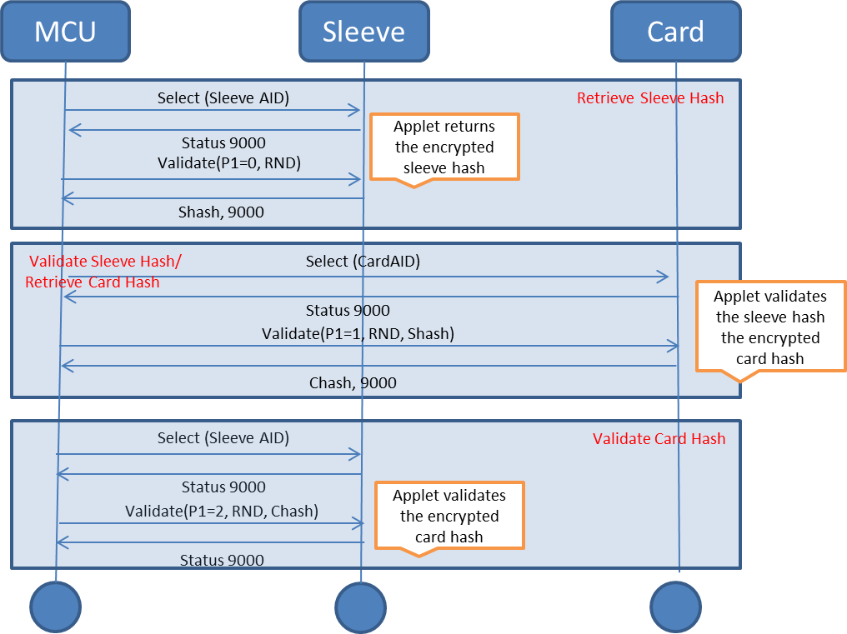

D.2 Add and update a new card
The following sequence chart illustrates how a payment card may be added.

Initially the handset sends the UI string and the sensitive information to the Jacket – this should be encrypted with the Jacket public key. The initial state of the card will be inactive as it has not been personalized yet.

The handset can then send the request to the MDES to initiate personalization.

As some point later when MDES has personalized the Radiius server will be notified and some information may be downloaded to the handset – for example the image, purpose, AID, display name etc.

The handset initiates an update to save this information in the Jacket SE.
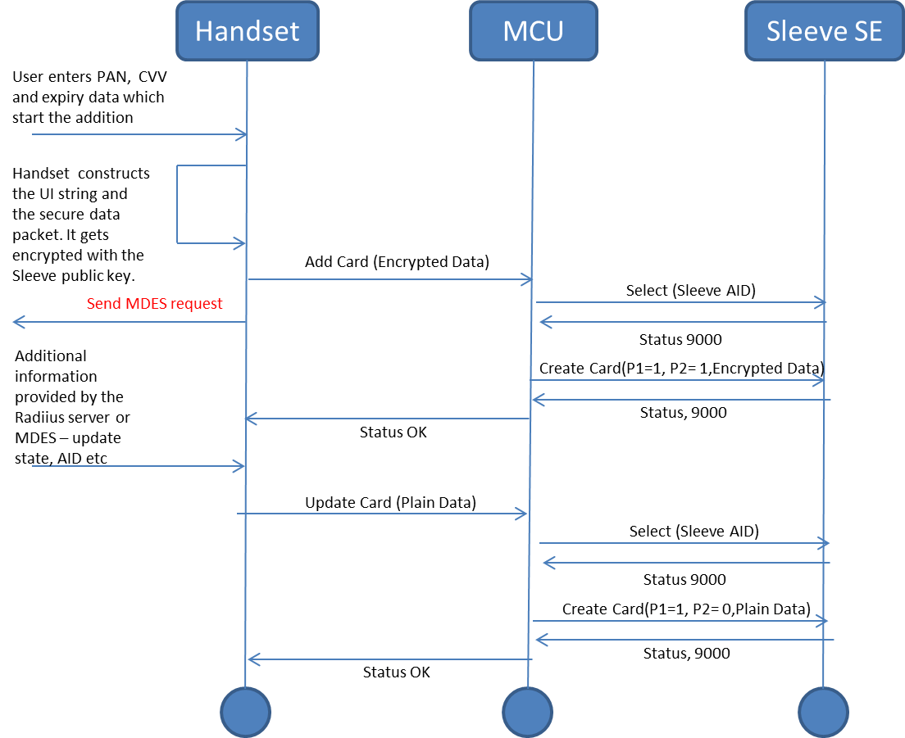

D.3 Card selection and lock
The following sequence chart show the APDU exchanges required when selection and locking a payment card.
Note: that the APDU issued to the payment applet is scheme dependent.

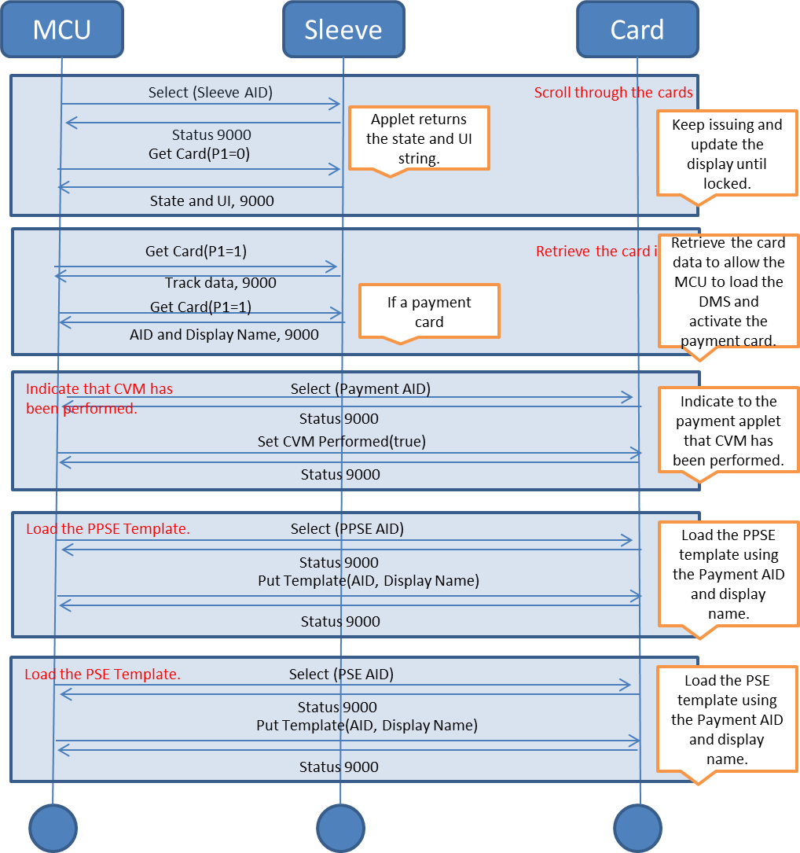

D.4 Pair with the handset
The following sequence chart illustrates the procedure that occurs when the handset pairs with the Jacket.

Note: that this assumes that the handset and Jacket have already been paired, if that isn’t the case the sequence follows the same procedure BUT the applet will recognize that this is a new pairing and retain the handset signature.
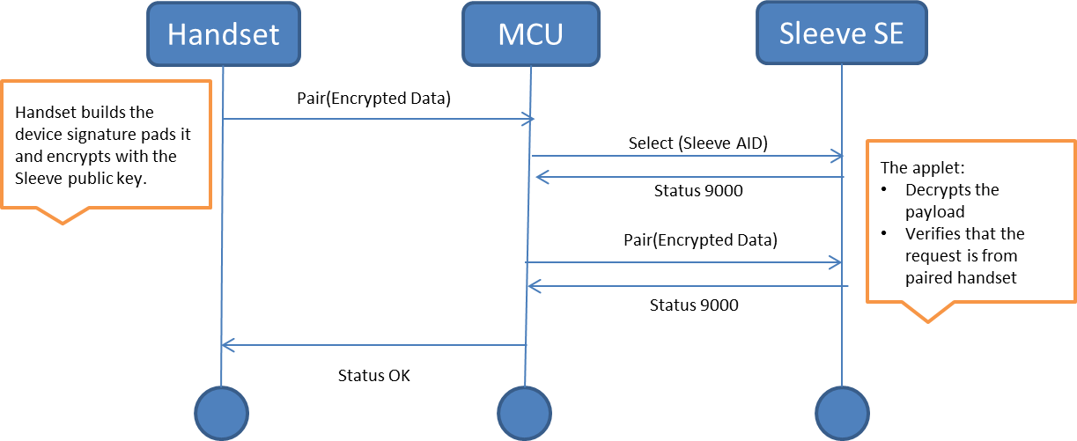

D.5 Retrieve the secure data

The secure data is requested by the handset when an e-commerce transaction is going to be made.

